WEBSCRAPING PROJECT ON NYKAA


DESCRIPTIONS :

Jewellery web scrapping on nykaa project involves extracting data from websites. This data can be used for various purposes, such as data analysis, research, reporting, or populating databases. We are going to use jewellery to scrape site. To do so, we are going to use tools like Python, Requests, BeautifulSoup.

OUTLINE:

From this site, we are going to grab the following information:

- Jewellery Name

- Price

- Reviews

STEPS:

Choose the Website and Webpage URL

The first step is to select the website you want to scrape. We will try to extract data on jewellery on the website.

Inspect the website

Now the next step is to understand the website structure. Understand what the attributes of the elements that are of your interest are. Right click on the website to select “Inspect”. This will open HTML code. Use the inspector tool to see the name of all the elements to use in the code.

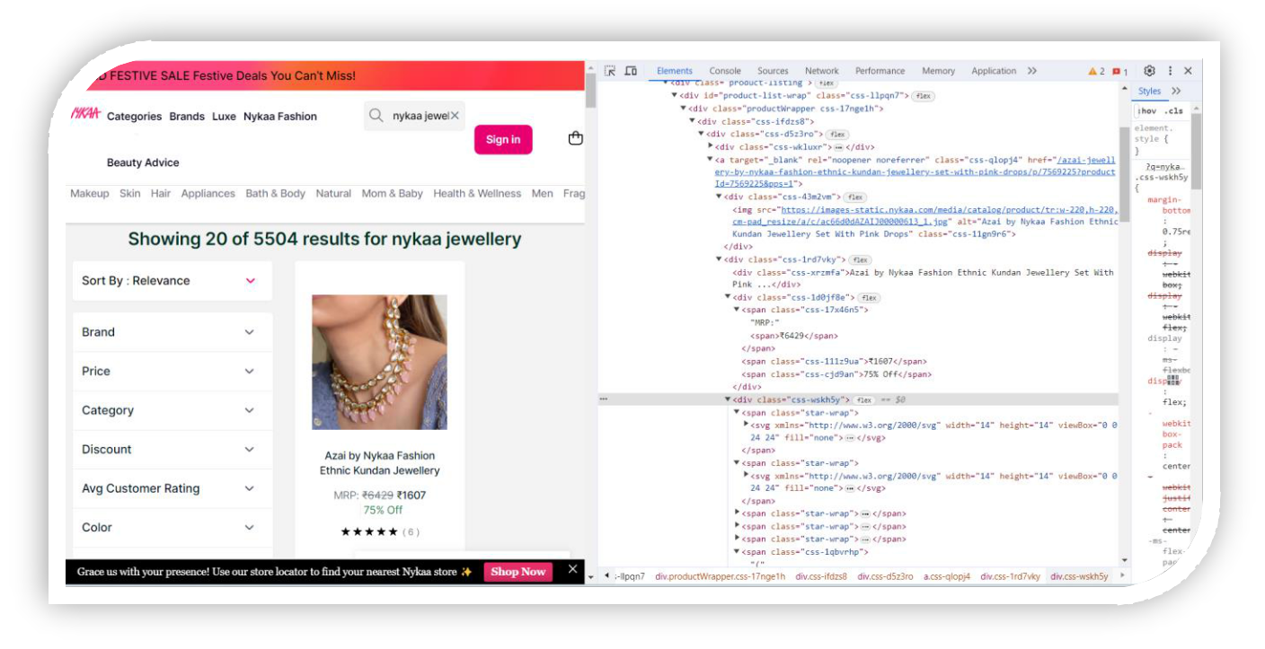
Installing the important libraries

Python has several web scrapping libraries. We will use the following libraries:

- Requests – for making HTTP requests to website

- BeautifulSoup – for parsing the HTML code

- Pandas – for storing the scraped data in data frame

Write the Python source code

We’ll write the main python code. The code will perform the following steps:

- Using requests to send an HTTP GET requests

- Using BeautifulSoup to parse the HTML code

- Extracting the required data from the HTML code

- Store the information in a pandas dataframe

Exporting the extracted data

We’ll export the data as a CSV file. We will use the pandas library. We’ll use the pandas library.

BENEFITS:

- Access to valuable data for analysis or research.

- Automation of data collection, saving time and effort.

- Stay up to date with change changes on the target websites.

Risk:

- Legal issues related to web scraping.

- Technical challenges due to website changes

Nykaa Jewellery Web Scraping Coding:

- Access nykaa website by using import requests URL and BeautifulSoup library.

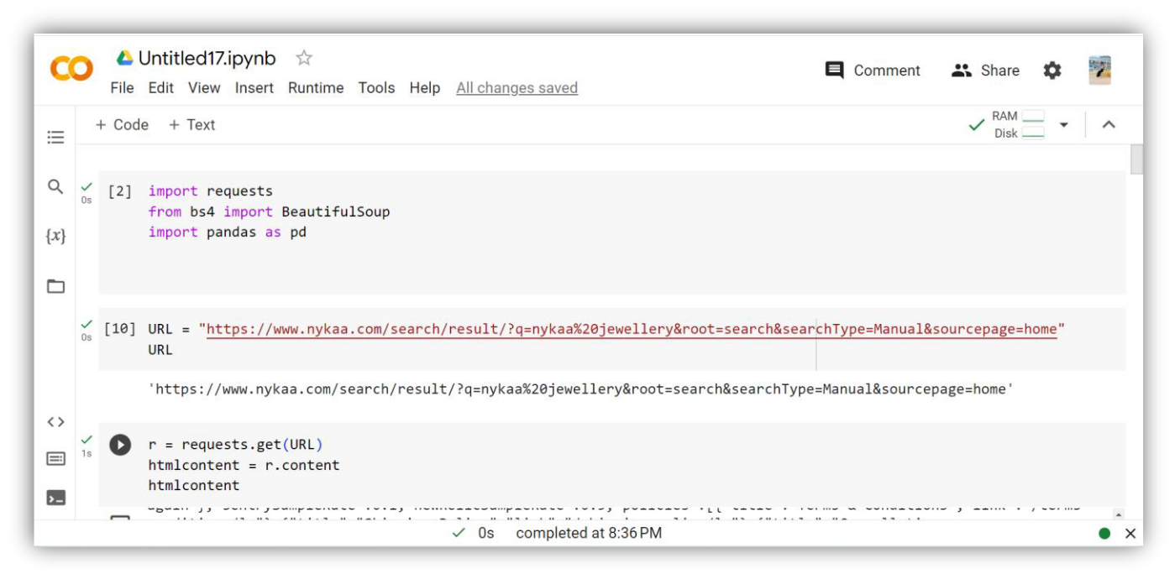

2. Parse the HTML

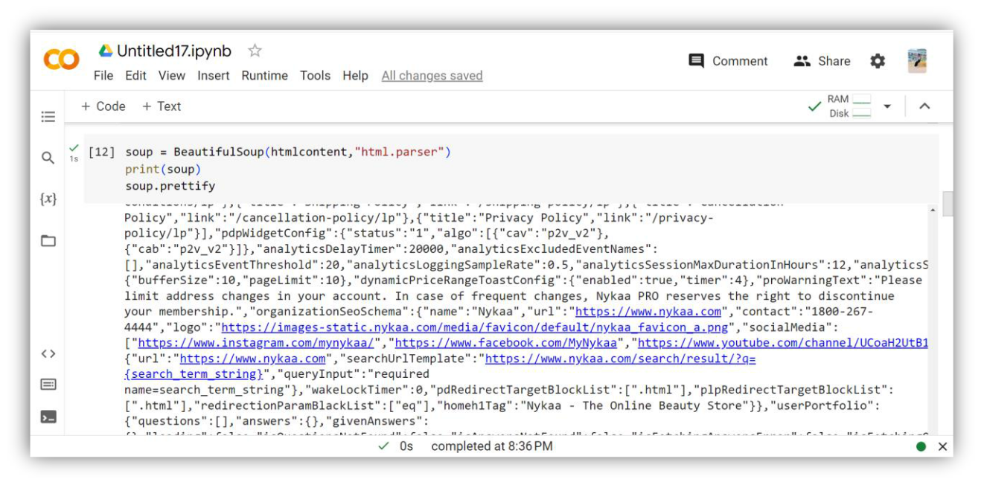

3. Access Nykaaa Jewellery Name using this source code.

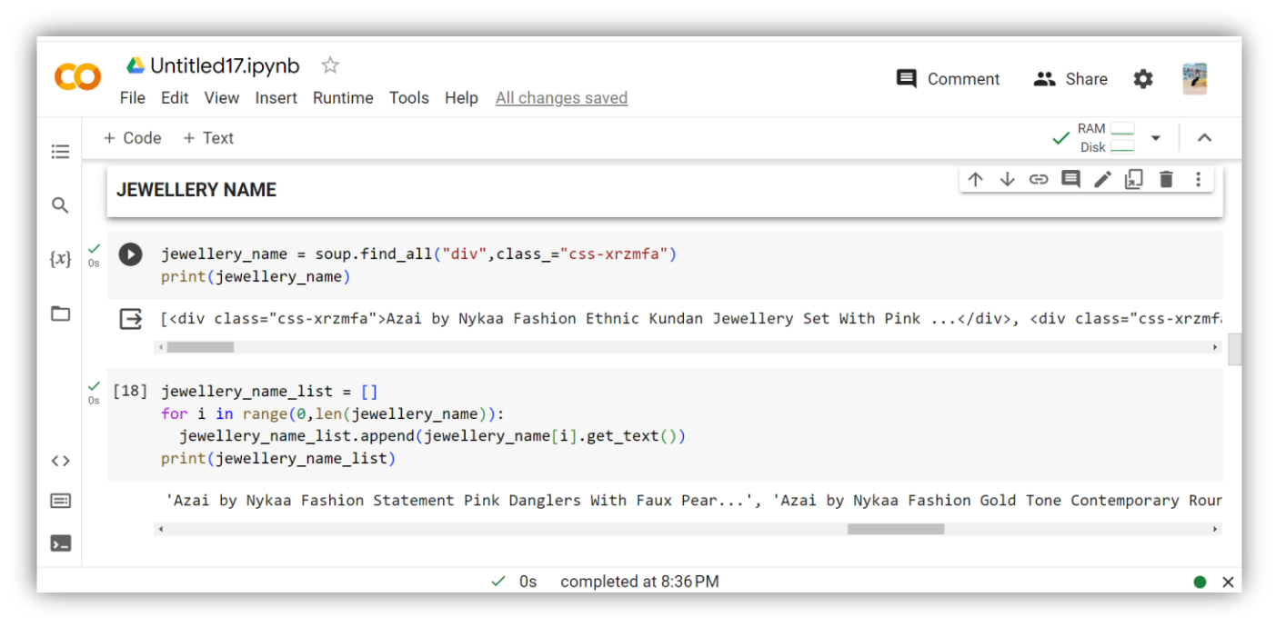

4. Access Nykaa Jewellery Prices using this source code.

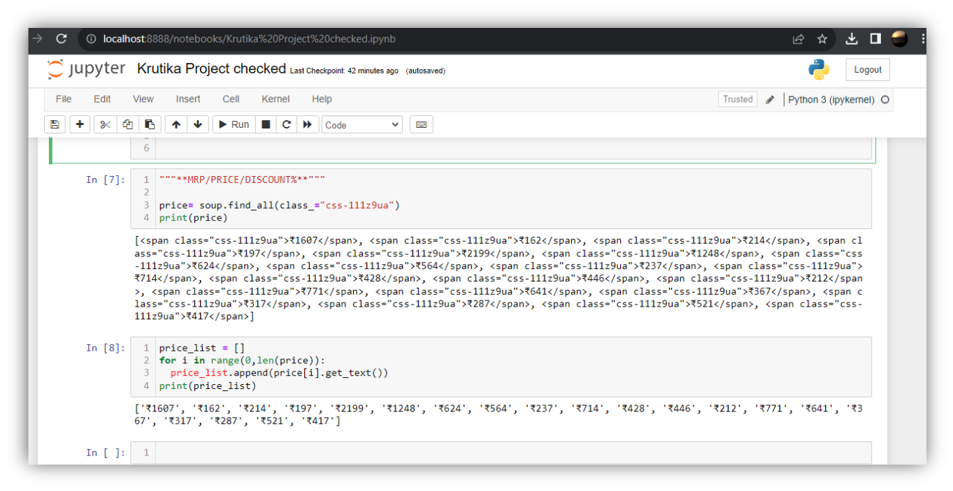
5. Access Nykaa Jewellery Reviews by Using this source code.

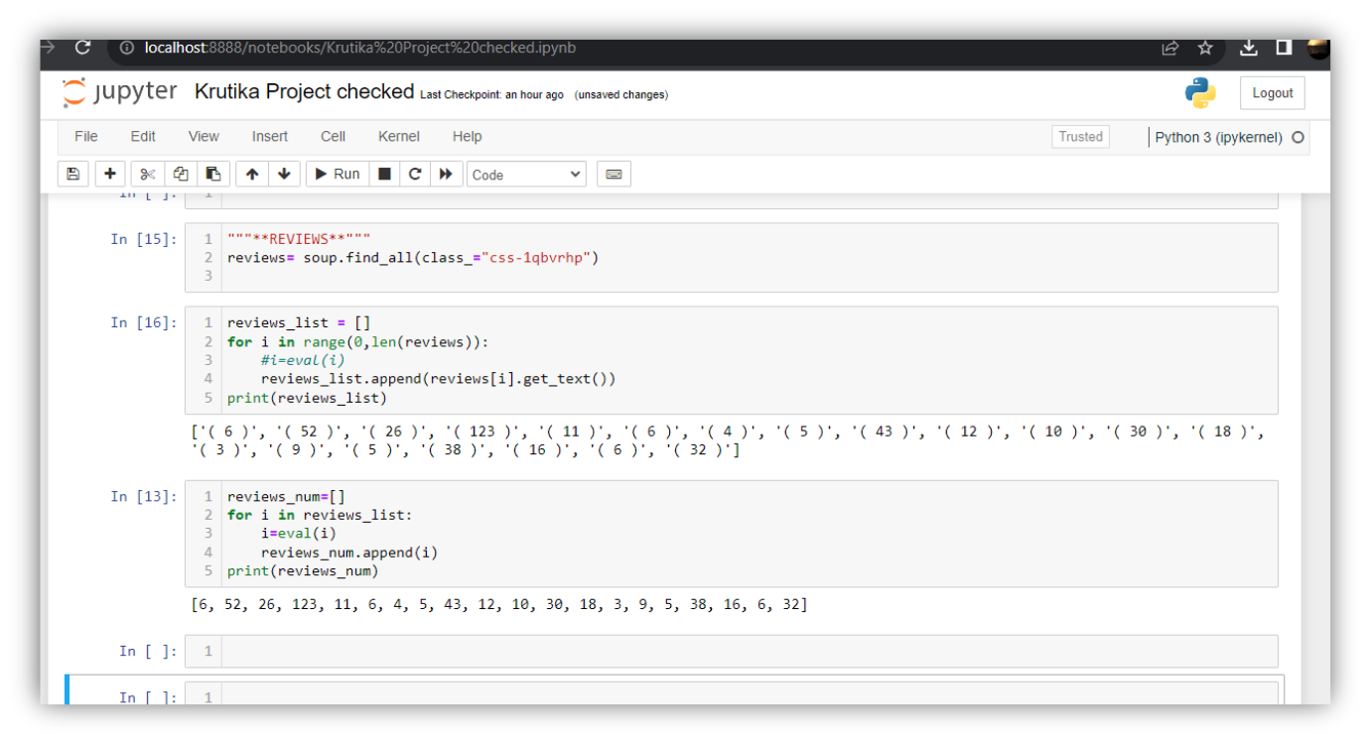

6. Arrange all the data using import pandas library.

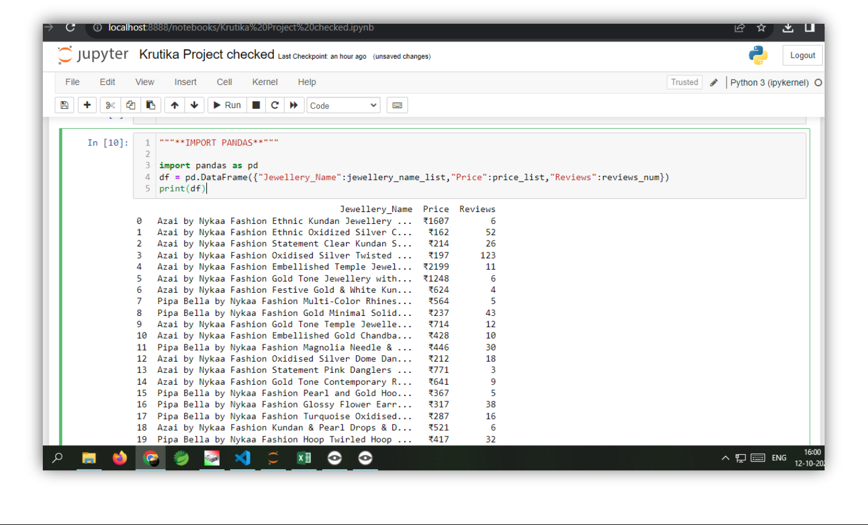

7. Store above all data in CSV file and again open this file in application.

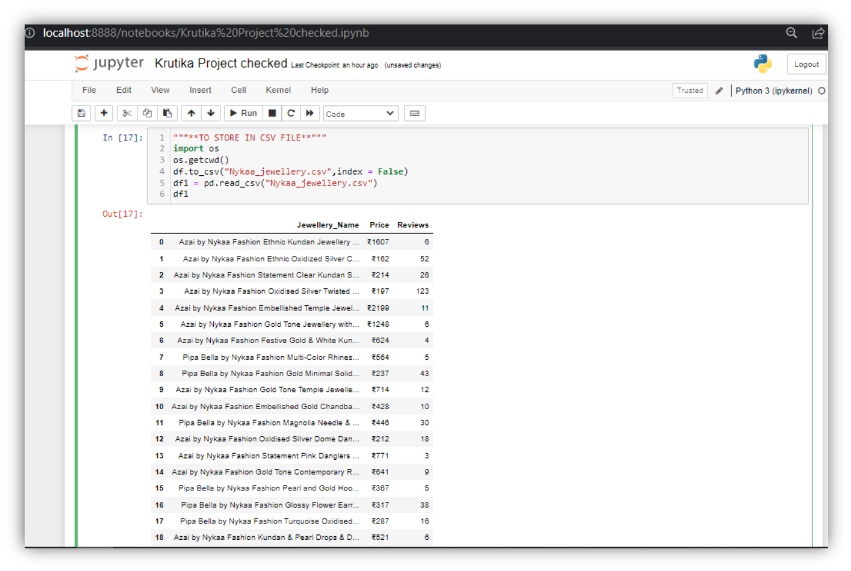
In conclusion, data scraping is a powerful technique to automatically extract information from websites. It is important to use web scraping responsibly and be mindful of the website’s performance to avoid any legality issues.

This is all for my Nykaa Jewellery web scraping project.



